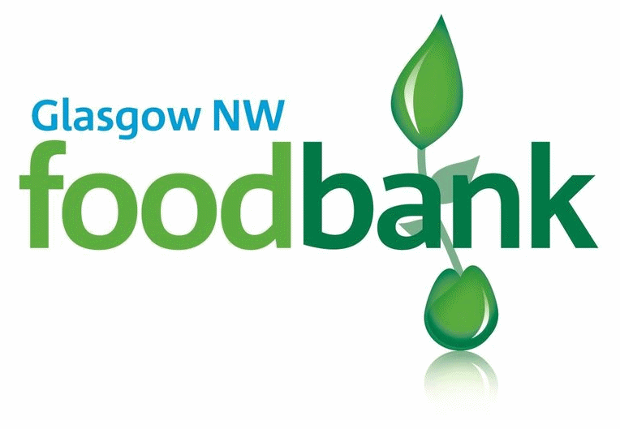

Volunteer Application Form

Thank you for your offer to help with Glasgow NW Foodbank. In order for us to process your application please would you answer the following questions:
(If you have any questions about your application or would like help completing it please contact the Project Manager)
References (not family members please)
Referee 1
Name:

Daytime tel. number or email address:

Relationship to you:

Referee 2
Name:

Daytime tel. number or email address:

Relationship to you:
Title:
Full Name:

Address:

Postcode:
Tel No:
Email:
Date of Birth:

Next of Kin:
Name:
Tel No:
Relationship:
Contact in case of emergency (if different)
Name:
Tel No:
Relationship:

I would be interested in helping regularly in the following area(s):
- Foodbank Centre Warehouse
- Maintenance/DIY Assisting in the office
Marketing/Public relations Fundraising
Supermarket collections Delivery or Collections (using own vehicle)
Specialist skills:

I am available for: (please tick and circle as appropriate)
One off events i.e. Supermarket collections, Harvest food sorting, annual stocktake
1-4 hours a week AM / PM on: Mon / Tues / Wed / Thurs / Fri / Sat
Full Day(s) on: Mon / Tues / Wed / Thurs / Fri / Sat
Other:

Do you have a clean driving licence? (not necessary for all roles) Yes No

Do you have any health problems that we should be aware of? Yes No
If yes, please give details:

Please tell us your previous work experience or qualifications:

Would you be willing to for us to submit for a DBS criminal record check, if required? Yes No

Do you have any criminal convictions (except those ‘spent’ under the Rehabilitation of Offenders Act 1974)? (NB: this does not necessarily prevent you from volunteering) Yes No
If yes, please give details:

Please state your reasons for volunteering:

Please give us any information you think may be useful to us:

How did you hear about volunteering at Glasgow NW foodbank?

Data protection: Glasgow NW foodbank will hold your details on file but will not release them to a third party.
I confirm that the above information is complete and correct. I consent to the processing of this data in the consideration of my application and during the course of my volunteering, if applicable.
Signature: Date:
Signature of parent/guardian if applicant is under 18: Date:
Thank you!
Please return completed form to: info@glasgownw.foodbank.org.uk

