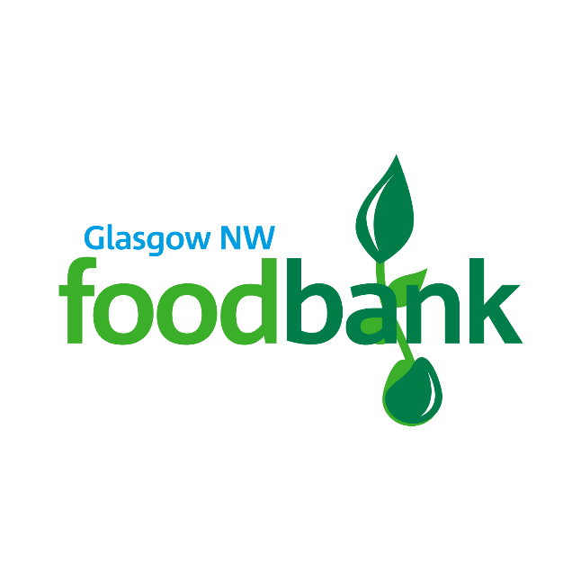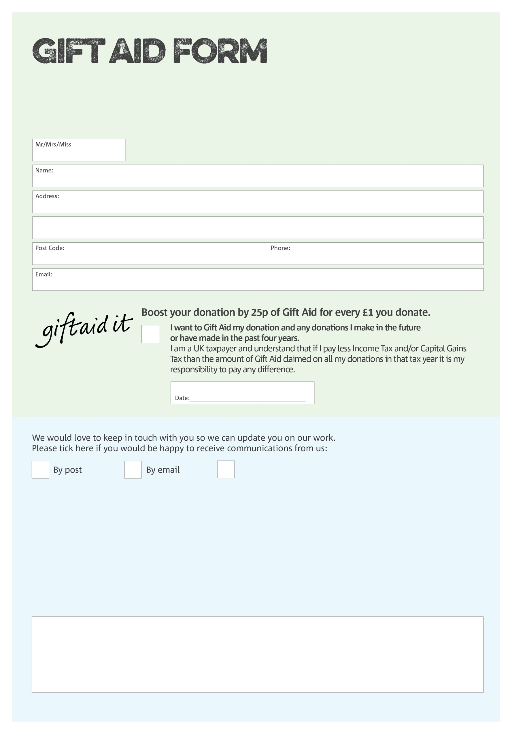

By filling in this form Glasgow NW Foodbank will receive an extra 25p for every £1 you give at no extra cost to you. Thank you!



You can change your preferences any time contacting us on 07787334012 or emailing us at info@glasgownw.foodbank.org.uk

Glasgow NW Foodbank is facilitated by Blawarthill Parish Church of Scotland, Glasgow, Reg. Charity No:SC006410 | Reg. in Scotland

POSTAL ADDRESS: Glasgow NW Foodbank, Blawarthill Parish Church, Millbrix Avenue, GLASGOW, G14 0EP

**Data protection**

*'Glasgow NW Foodbank is committed to protecting your privacy and will process your personal data in accordance with current Data Protection legislation. Glasgow NW Foodbank collects information to keep in touch with you and supply you with information relating to our work. To unsubscribe from our newsletter, send a message to the email address above with the word unsubscribe in the subject line. A full data privacy statement for financial donors is available from the foodbank on request.’*

I do not wish to receive future communications from Glasgow NW Foodbank

We would love to know why you have chosen to donate to Glasgow NW Foodbank. If you would like to share your motivation let us know below: